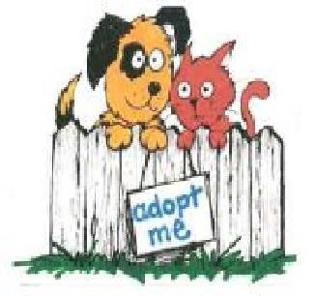
Animal License 2023
900 E. Railroad Ave, Fort Morgan, CO 80701
Phone: (970)-542-6416

The city of Fort Margan passed an animal licensing ordinance that is required each year. All cat and dog licenses can be obtained on January 1, 2023, at The Fort Morgan Humane Society located at 900 East Railroad Avenue, Fort Morgan, CO 80701 during regular shelter hours.
Current fees established by the City for the 2023 license are as follows:
For both Dogs and Cats
Under one year of age and Spayed/Neutered: $15.00 per year.
Over one year of age, not Spayed/Neutered: $30.00 per year.
Owners Application:
Full Name: _______________________________________________________________________________
Address: _________________________________________________________________________________
Home Number: _____________________________ Cell Number: __________________________________
Email Adress: __________________________________________________________________
New License: _______________________________ Renewal License: _______________________________
Pet Information: Dog | Cat (circle one)
Breed: ___________________ /___________________ (most prominent breed and secondary breed)
Color: ________________________________________ Sex: M | F Spayed: Yes | No
Proof of Spay/Neuter must be submitted with the first application.
Is your pet Microchipped: Yes | No If yes, microchip number: __________________________________
Rabies Tag number: ____________________________ Expiration Date: ______________________________

Pet Information: Dog | Cat (circle one)
Breed: ___________________ /___________________ (most prominent breed and secondary breed)
Color: ________________________________________ Sex: M | F Spayed: Yes | No
Proof of Spay/Neuter must be submitted with the first application.
Is your pet Microchipped: Yes | No If yes, microchip number: __________________________________
Rabies Tag number: ____________________________ Expiration Date: ______________________________

Pet Information: Dog | Cat (circle one)
Breed: ___________________ /___________________ (most prominent breed and secondary breed)
Color: ________________________________________ Sex: M | F Spayed: Yes | No
Proof of Spay/Neuter must be submitted with the first application.
Is your pet Microchipped: Yes | No If yes, microchip number: __________________________________
Rabies Tag number: ____________________________ Expiration Date: ______________________________

Pet Information: Dog | Cat (circle one)
Breed: ___________________ /___________________ (most prominent breed and secondary breed)
Color: ________________________________________ Sex: M | F Spayed: Yes | No
Proof of Spay/Neuter must be submitted with the first application.
Is your pet Microchipped: Yes | No If yes, microchip number: __________________________________
Rabies Tag number: ____________________________ Expiration Date: ______________________________

All animals must be in possession of a city license whenever they are off your premises. ALL LICENSES EXPIRE ON THE 31ST OF DECEMBER EACH YEAR.

Thank you for registering your pet(s), once you have completed filling out the license please stop by the shelter and register your pet(s).

Very respectfully,

Fort Margan Humane Society
Fortmorganhumanesociety.com
900 E. Railroad Ave, Fort Morgan, CO 80701
Phone: (970)-542-6416
fortmorganhumanesociety2@gmail.com

